We were with our families sitting there
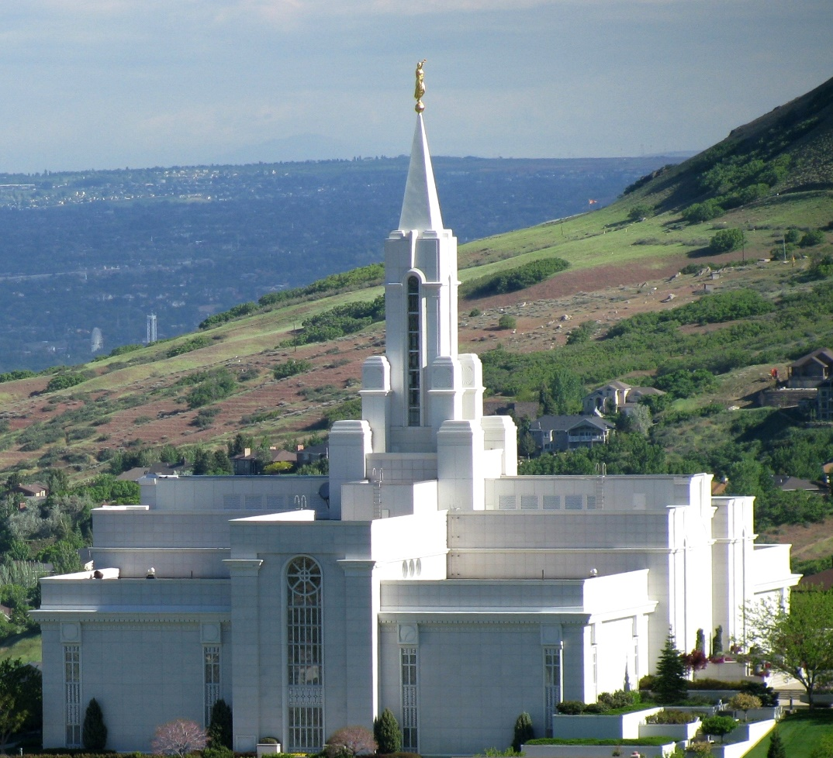
To the temple we had come.

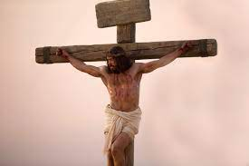
To talk about the signs and wonders and the death of God’s own Son.
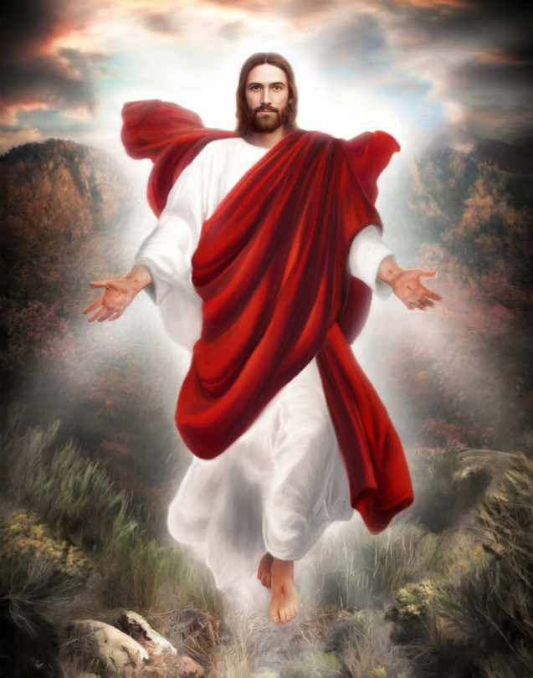
When within our hearts we heard a voice, and we looked up to the sky.
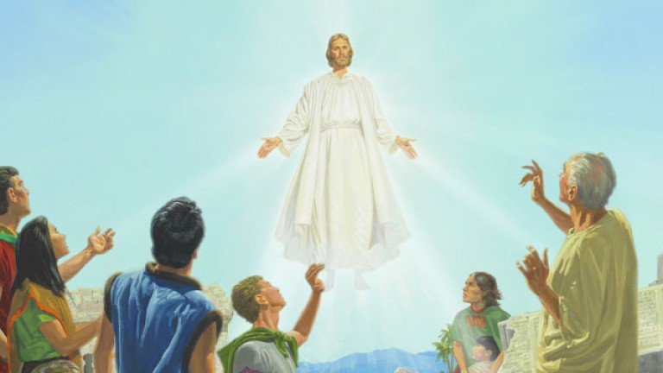
We didn’t understand at first, but then heard the voice from on high.
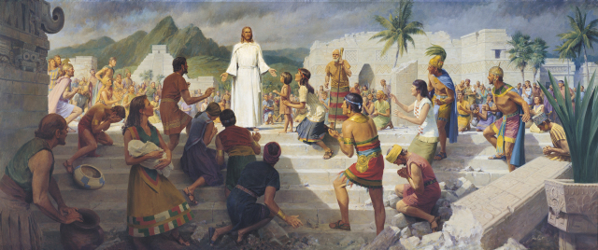
He had come! He had come to the place where we gathered.

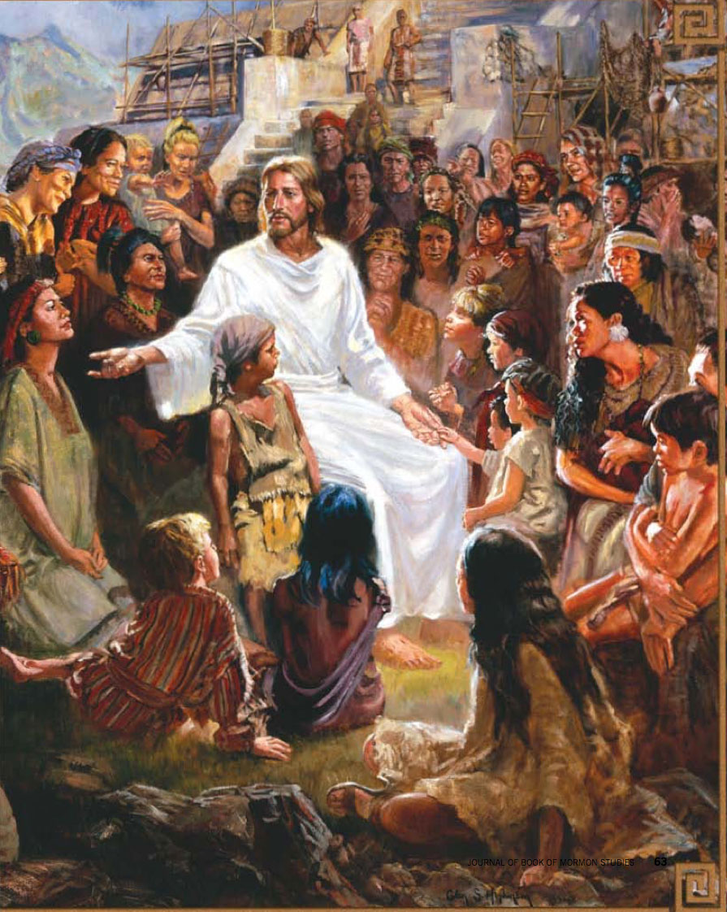
He had come! He had come, to be with us here.
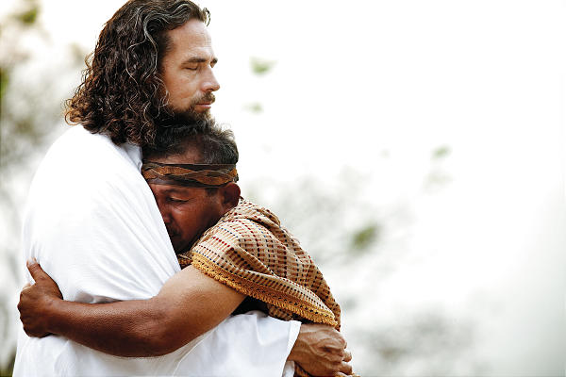
I’ll remember His voice and the look on His face.
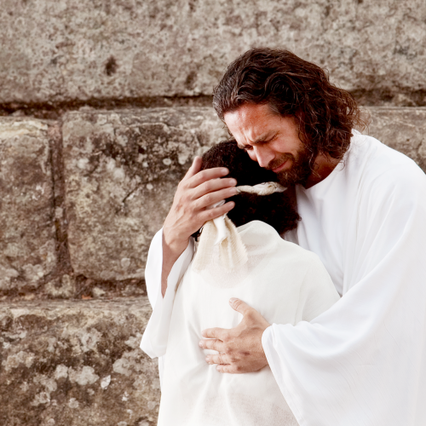
I’ll remember this day when I felt His embrace.
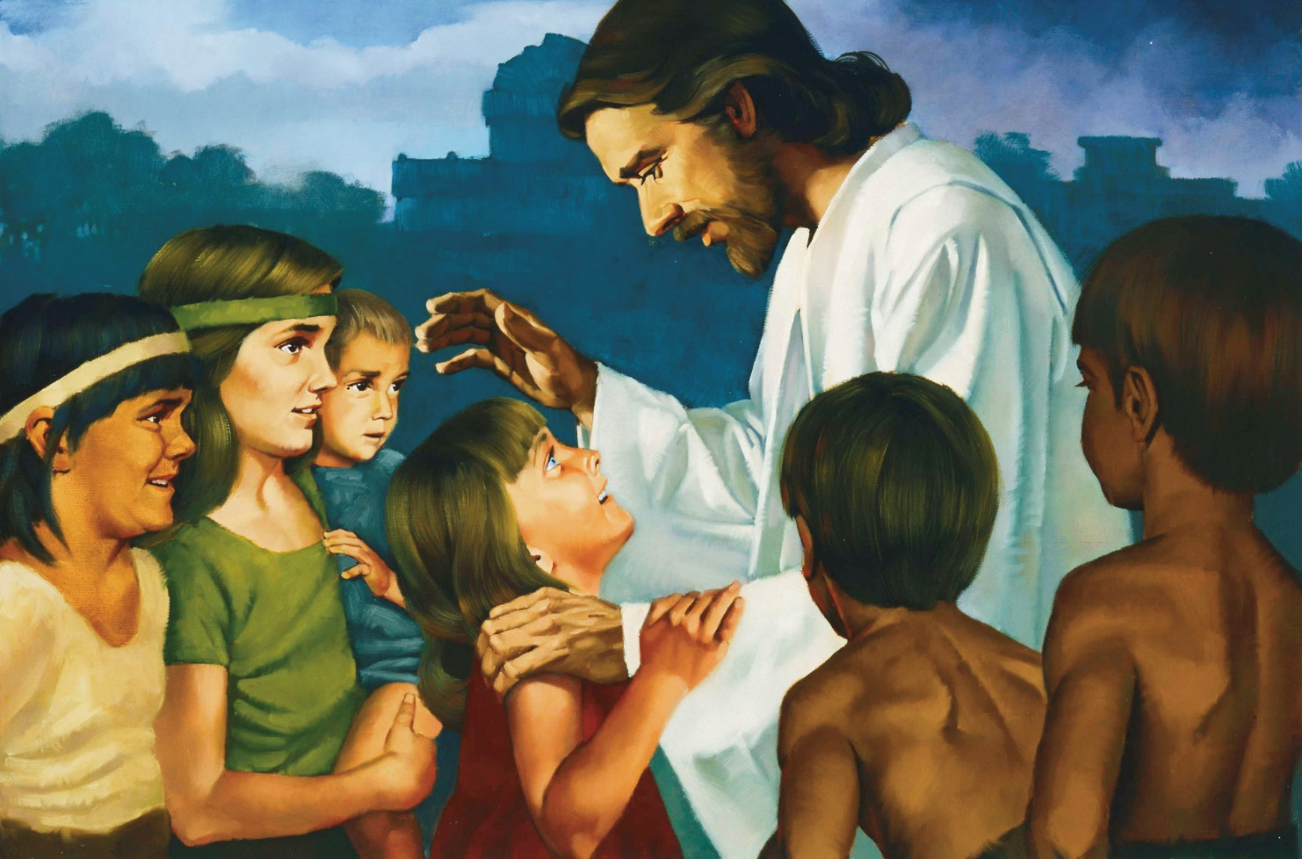
He told our parents to let us come to gather round his knee.
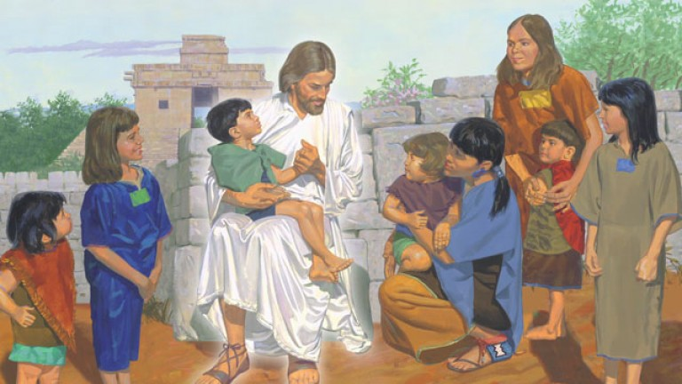
He took us each one by one. He prayed just for me.
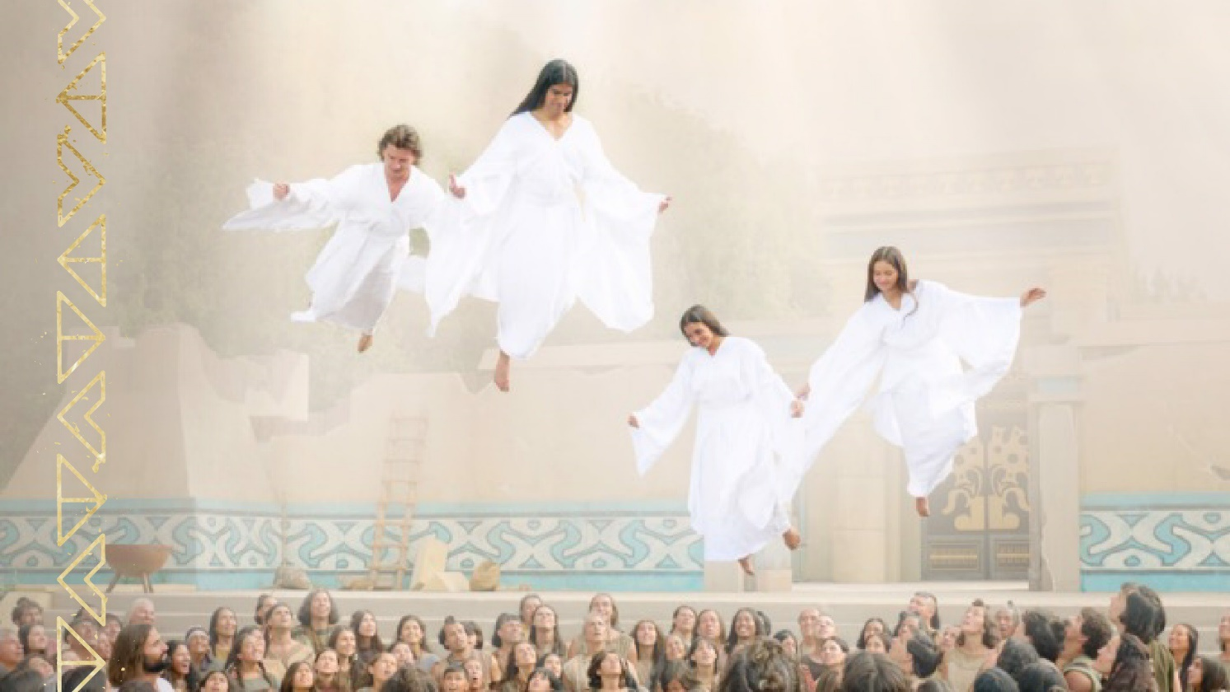
We looked up to the heavens and we saw them coming down.
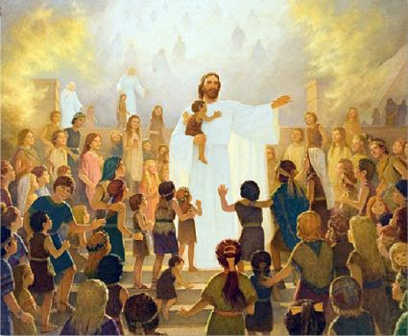
The angels had come to be with us, and they came all around.
He had come! He had come to the place where we gathered.

He had come! He had come, to be with us here.
I’ll remember His voice and the look on His face.
I’ll remember this day when I felt His embrace.

